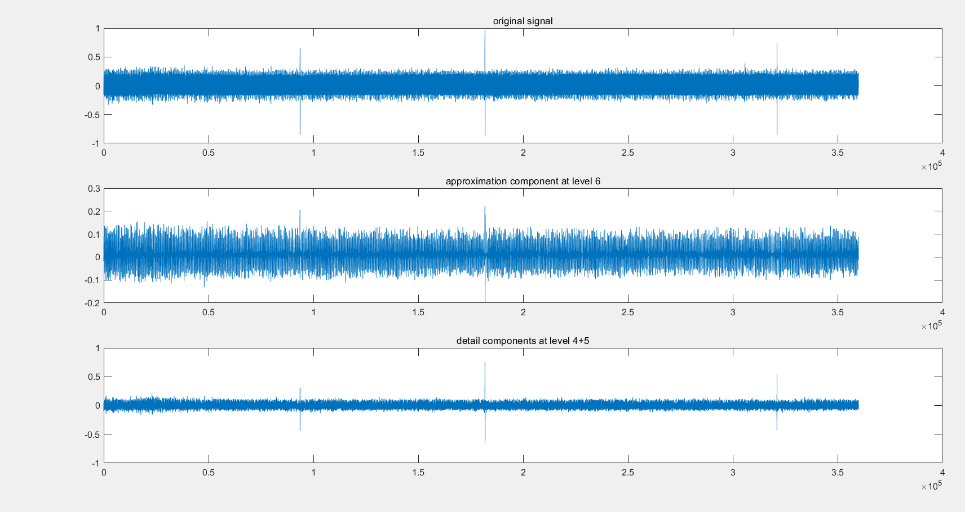Detail components at level 4+5 is Father wavelet, That is, the scaling function;

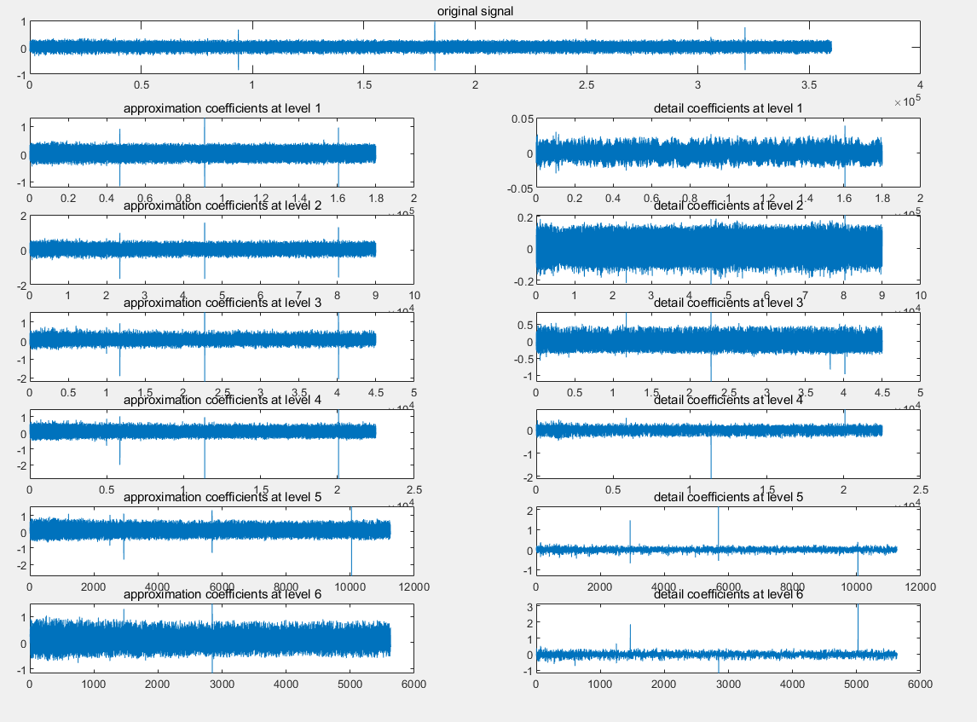approximation component at level 6 is Mother wavelet, That is, Wavelet function;

The best mother wavelet is approximation coefficients at level 2